You have a Python application packaged as a Docker image (version v1) stored on Docker Hub. Your task is to deploy this application to a Kubernetes cluster, ensuring it runs with 3 replicas. After the deployment, the Python application is updated, and a new Docker image (version v2) is pushed to Docker Hub. You need to update the existing deployment to use the new version.

Describe the sequence of commands or YAML configuration you would use to accomplish this task.

1. Deployment of pod s- yaml file screenshot

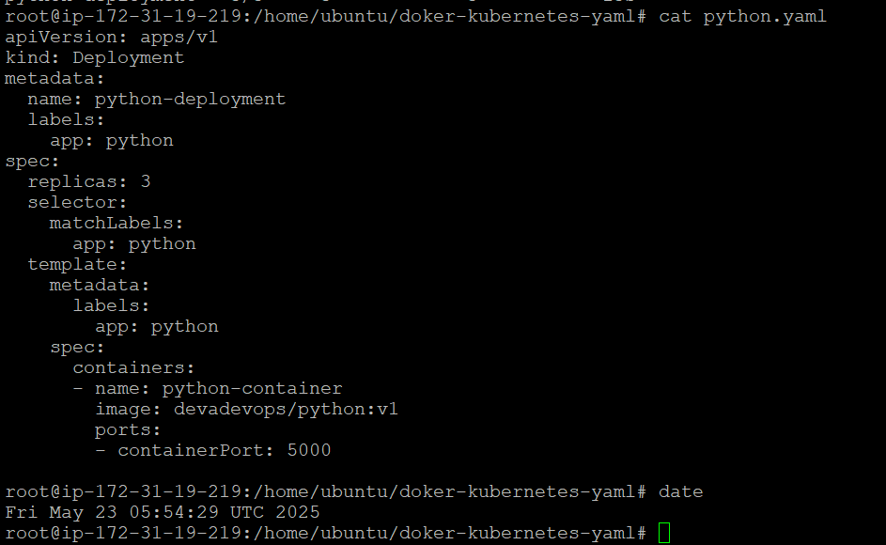

Kubectl describe command of deployment of showing version 1.0 image is deployed

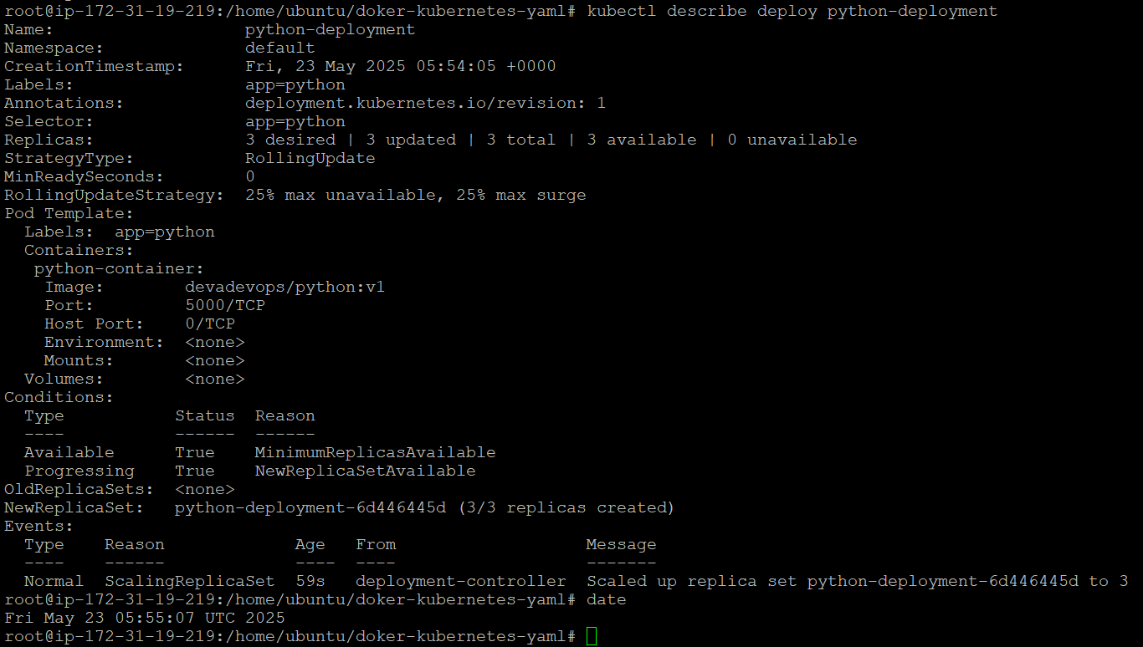

Upgrade command to version 2.0 image



Kubectl describe command of deployment of showing version 2.0 image is deployed

